JM612-V8 Explosion Proof Robot Speed Dome
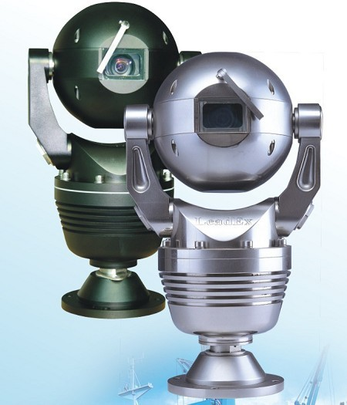

The body of JM612-V8 Robot Series are machined from 8mm~22mm thick 6063# Aluminum Alloy or 316# Stainless Steel. They are integrated with Sony 530TVL Day/Night Cameras and 360 degree continuous Pan/Tilt rotation. The solid dome body is designed and has been proven to be explosion proof and to be resistant to the impact from stones, bricks, normal explosion and even short gun bullets. CNEx/CQST with Ex-proof standard EXd II CT6, and with their assigned related certificate have formally accredited the JM612-V8 Robot Series.

The JM612-V8 Series dome body is integrated with the special 5-proofs design. That is: Bullet proof, Vandal proof, Water proof, Corrosion proof and Explosion proof. Because of its explosion proof design, it is very popular in “Hazardous Areas”, “Explosive Atmosphere” and related areas where flammable liquids, vapors, gases or combustible dusts are likely to occur in quantities sufficient enough to cause a fire or explosion.

Its own unique omni-seal waterproof and explosion proof design, coupled with its sound and solid dome body make it tailor made to be applied in : marine transportation, military foundation, perimeter protection, ammunition depot, jails, ports, nuclear facility, Oil refineries, rigs and offshore drilling platform, oil and gas stations, chemical plants, embassies, airports, city surveillance, government, banks and vehicles (off-road vehicles, police cars, military vehicles) etc.
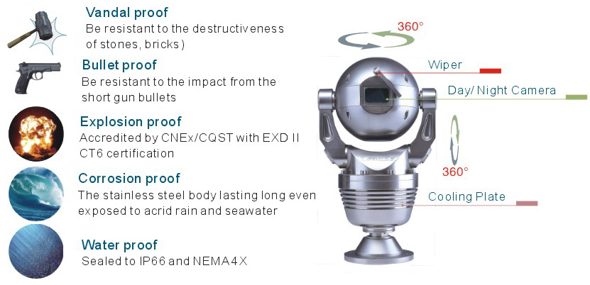
- Explosion proof (Accredited by CNEx/CQST with EXD II CT6 certification)
- Bullet proof (Resistant to the impact from normal explosions and short gun bullets)
- Vandal proof (Resistant to stones and bricks)
- Water proof (Sealed to IP66 and NEMA 4X)
- Corrosion proof (The stainless steel body lasts long even when exposed to acid rain and seawater)
- Integration of Day/Night camera, receiver, variable high-speed pan/tilt motor and enclosure
- JM612-V8 series are machined from 8mm~22mm thick Aluminum alloy or 316# Stainless Steel, coupled with its unique sound and solid dome body design, it efficiently prevents from any destructiveness that might threaten in normal use.
- Flat designed optics window from filmed and toughened glass (5mm thick) offers distortion free image and maximum vandal resistant protection for IOP (Integrated Optical Package) camera module
- Unique DIP switch design, provides ease of use.
- Motor calibration in manual or auto guarantee preset precise continuous running
- Alarm box and water pump system - optional
- IP66/CE/FCC/RoHS compliance
- Support with LeadEx firmware online remote upgrade module
- Optional built-in IP module

- Built-in Sony or Hitachi IOP camera module
- Back light compensation on/off selectable & WDR functions
- 8 Privacy Masking Zone and OSD password protection (Please see the camera parameters)

- OSD password protection
- User definable 128 target presets, 8 preset tours, video frozen
- Programmable Pattern & auto scan
- User definable power-up action and temperature control
- User definable left and right limitation, proportional Pan speed
- RS-485 communication port, RS-232, RS-422 - optional
- Compatible to Pelco P/D protocol and customized protocol - optional
- Auto / Manual zero calibration
- OSD programming menu, inside temperature and pan/tilt/zoom position
- Surge & non-volatile protection

- Aluminum alloy or (#316) stainless steel body: 8mm ~ 22mm
- Filmed and toughened glass: 5mm
- Continuing working temperature：-20°C -- +50°C
- Storage temperature: -40°C -- +60°C
- Net weight: 10KG (Al alloy), 24KG (Stainless Steel)
- Dimension: 370 x 212 mm (see chart)
- Packing Volume: 68 x 46.5 x 32.5 cm

- Input voltage: 18VAC~30VAC/ 18VDC~30VDC
- Maximum Power: 50VA

- Pan/tilt speed: Pan 0.1°~100°/s Tilt: 0.1 ° ~ 80° /s
- Preset speed: Pan 100° /s Tilt ：80 ° /s
- Preset accuracy: +/- 0.1° (auto /hand control.)
- Auto scan: 1°-40°/s
- Pan rotation: 360° Tilt rotation: 360°
The JM612-V8 Series dome body is integrated with the special 5-proofs design. That is: Bullet proof, Vandal proof, Water proof, Corrosion proof and Explosion proof. Because of its explosion proof design, it is very popular in “Hazardous Areas”, “Explosive Atmosphere” and related areas where flammable liquids, vapors, gases or combustible dusts are likely to occur in quantities sufficient enough to cause a fire or explosion.

Its own unique omni-seal waterproof and explosion design, coupled with its sound and solid dome body make it tailor made to be applied in many applications, that include: marine transportation, military foundation, perimeter protection, ammunition depot, jails, ports, nuclear facility, Oil refineries, rigs and offshore drilling platform, oil and gas station, chemical plants, embassies, airports, city surveillance, government, banks and vehicles (off-road vehicles, police cars, military vehicles) etc.

As an option, N2 Nitrogen gas (Maximum pressure within 150Kpa) could be filled into the dome body through a specially designed air vent valve. This could offer further protection to the inner parts, and adapt to the industry and marine related installation, like seaports, ships and chemical plants.
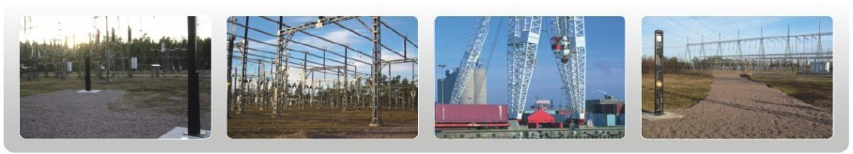

Camera | 18X Day/Night  (Sony FCB-EX490) | 26X Day/Night  (Sony FCB-EX490) | 36X Day/Night  (Sony FCB-EX1010)
Material | 18X Day/Night  (Sony FCB-EX490) | 26X Day/Night  (Sony FCB-EX490) | 36X Day/Night  (Sony FCB-EX1010)
Aluminum Alloy | JM612A-V8-18 | JM612A-V8-26 | JM612A-V8-36
316L# Stainless Steel | JM612S-V8-18 | JM612S-V8-26 | JM612S-V8-36

EXPLOSION-PROOF CERTIFICATE OF CONFORMITY
For JM612 ROBOT SPEED DOME

GENERAL INFORMATION:
LeadEx JM612 SERIES Robot Speed Dome Camera (also called Solid Speed Dome) is designed and proved to be explosion proof, accredited by CNEx/CQST (China National Quality Supervision and Test Center for explosion Protected Electrical Products), the legal professional testing and certification body in Explosion safety test, verification and approval.

CNEX/CQST is an IECEx (International Electrotechnical Commission Scheme for certification to standards for Explosive Atmospheres) testing laboratory in accordance with the IECEx scheme rules and procedures. And the lab is also authorized by Department of Energy of USA for NVLAP, and accredited by CNAL (China National Accreditation Board for Laboratories) and CCS (China Classification Society).

CQST signed the mutual acceptance and/or mutual understanding agreement with the laboratories such as UL (USA), PTB (Germany), NEMKO (Norway), FMRC (USA), TESTSAFE (Australia), LCIE (France), CCVE (Russia), CSA (Canada), BASEEFA (UK) and so on. (Agreement photocopies are available on request).

EXPLOSION TESTINGS WITH COMBUSTIBLE GAS:
The Robot Speed Dome Camera experienced explosion testing by combustible gas (METHAME & HYDROGEN) in different pressure conditions, with explosion from both inside and outside.
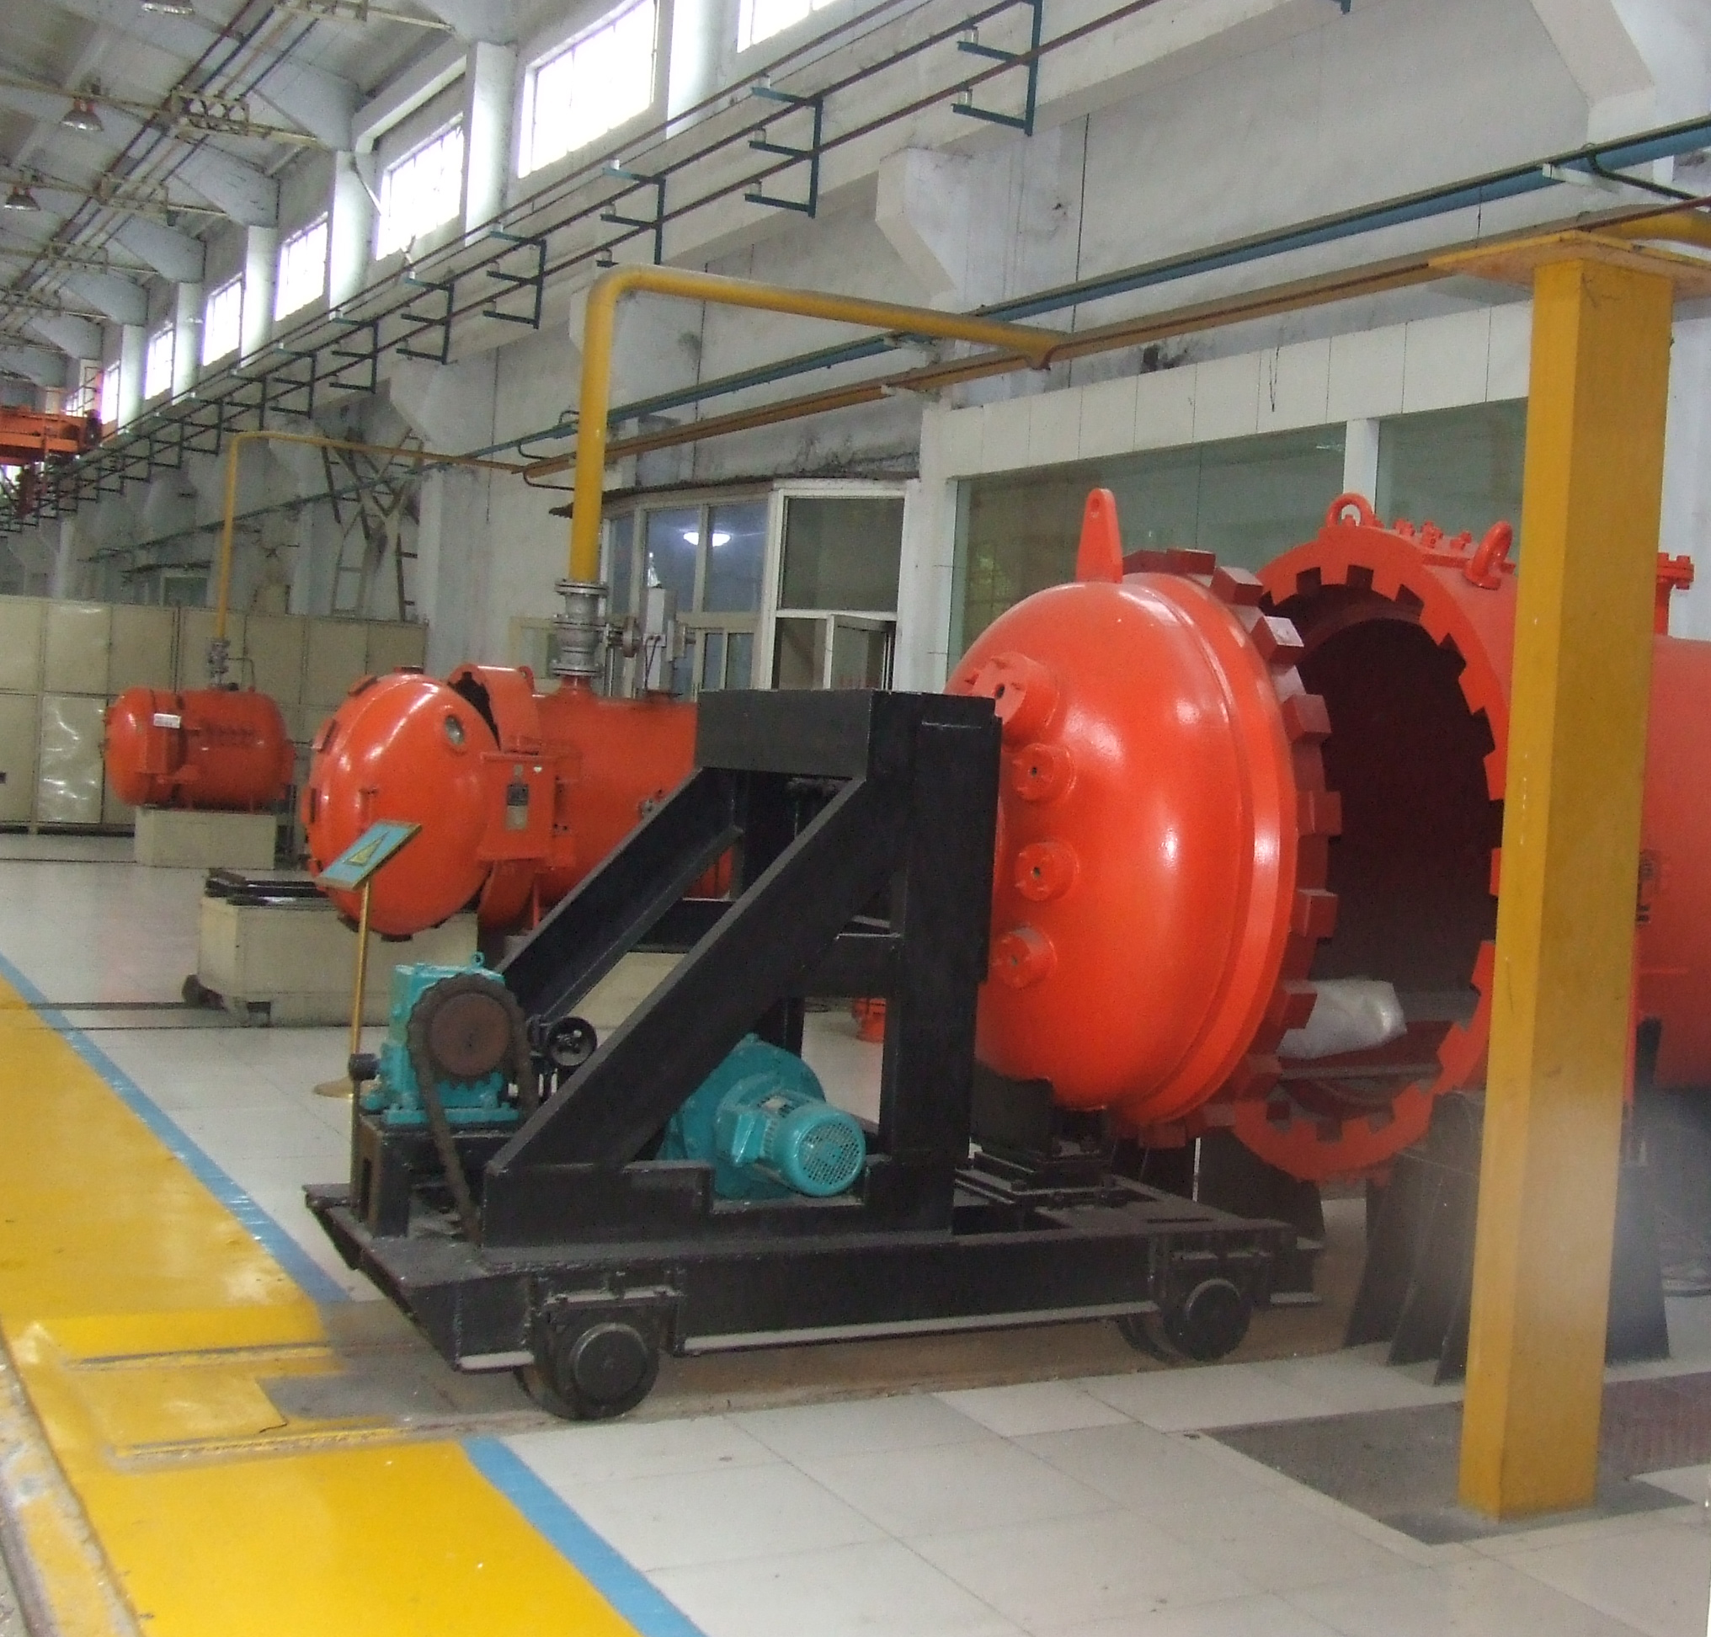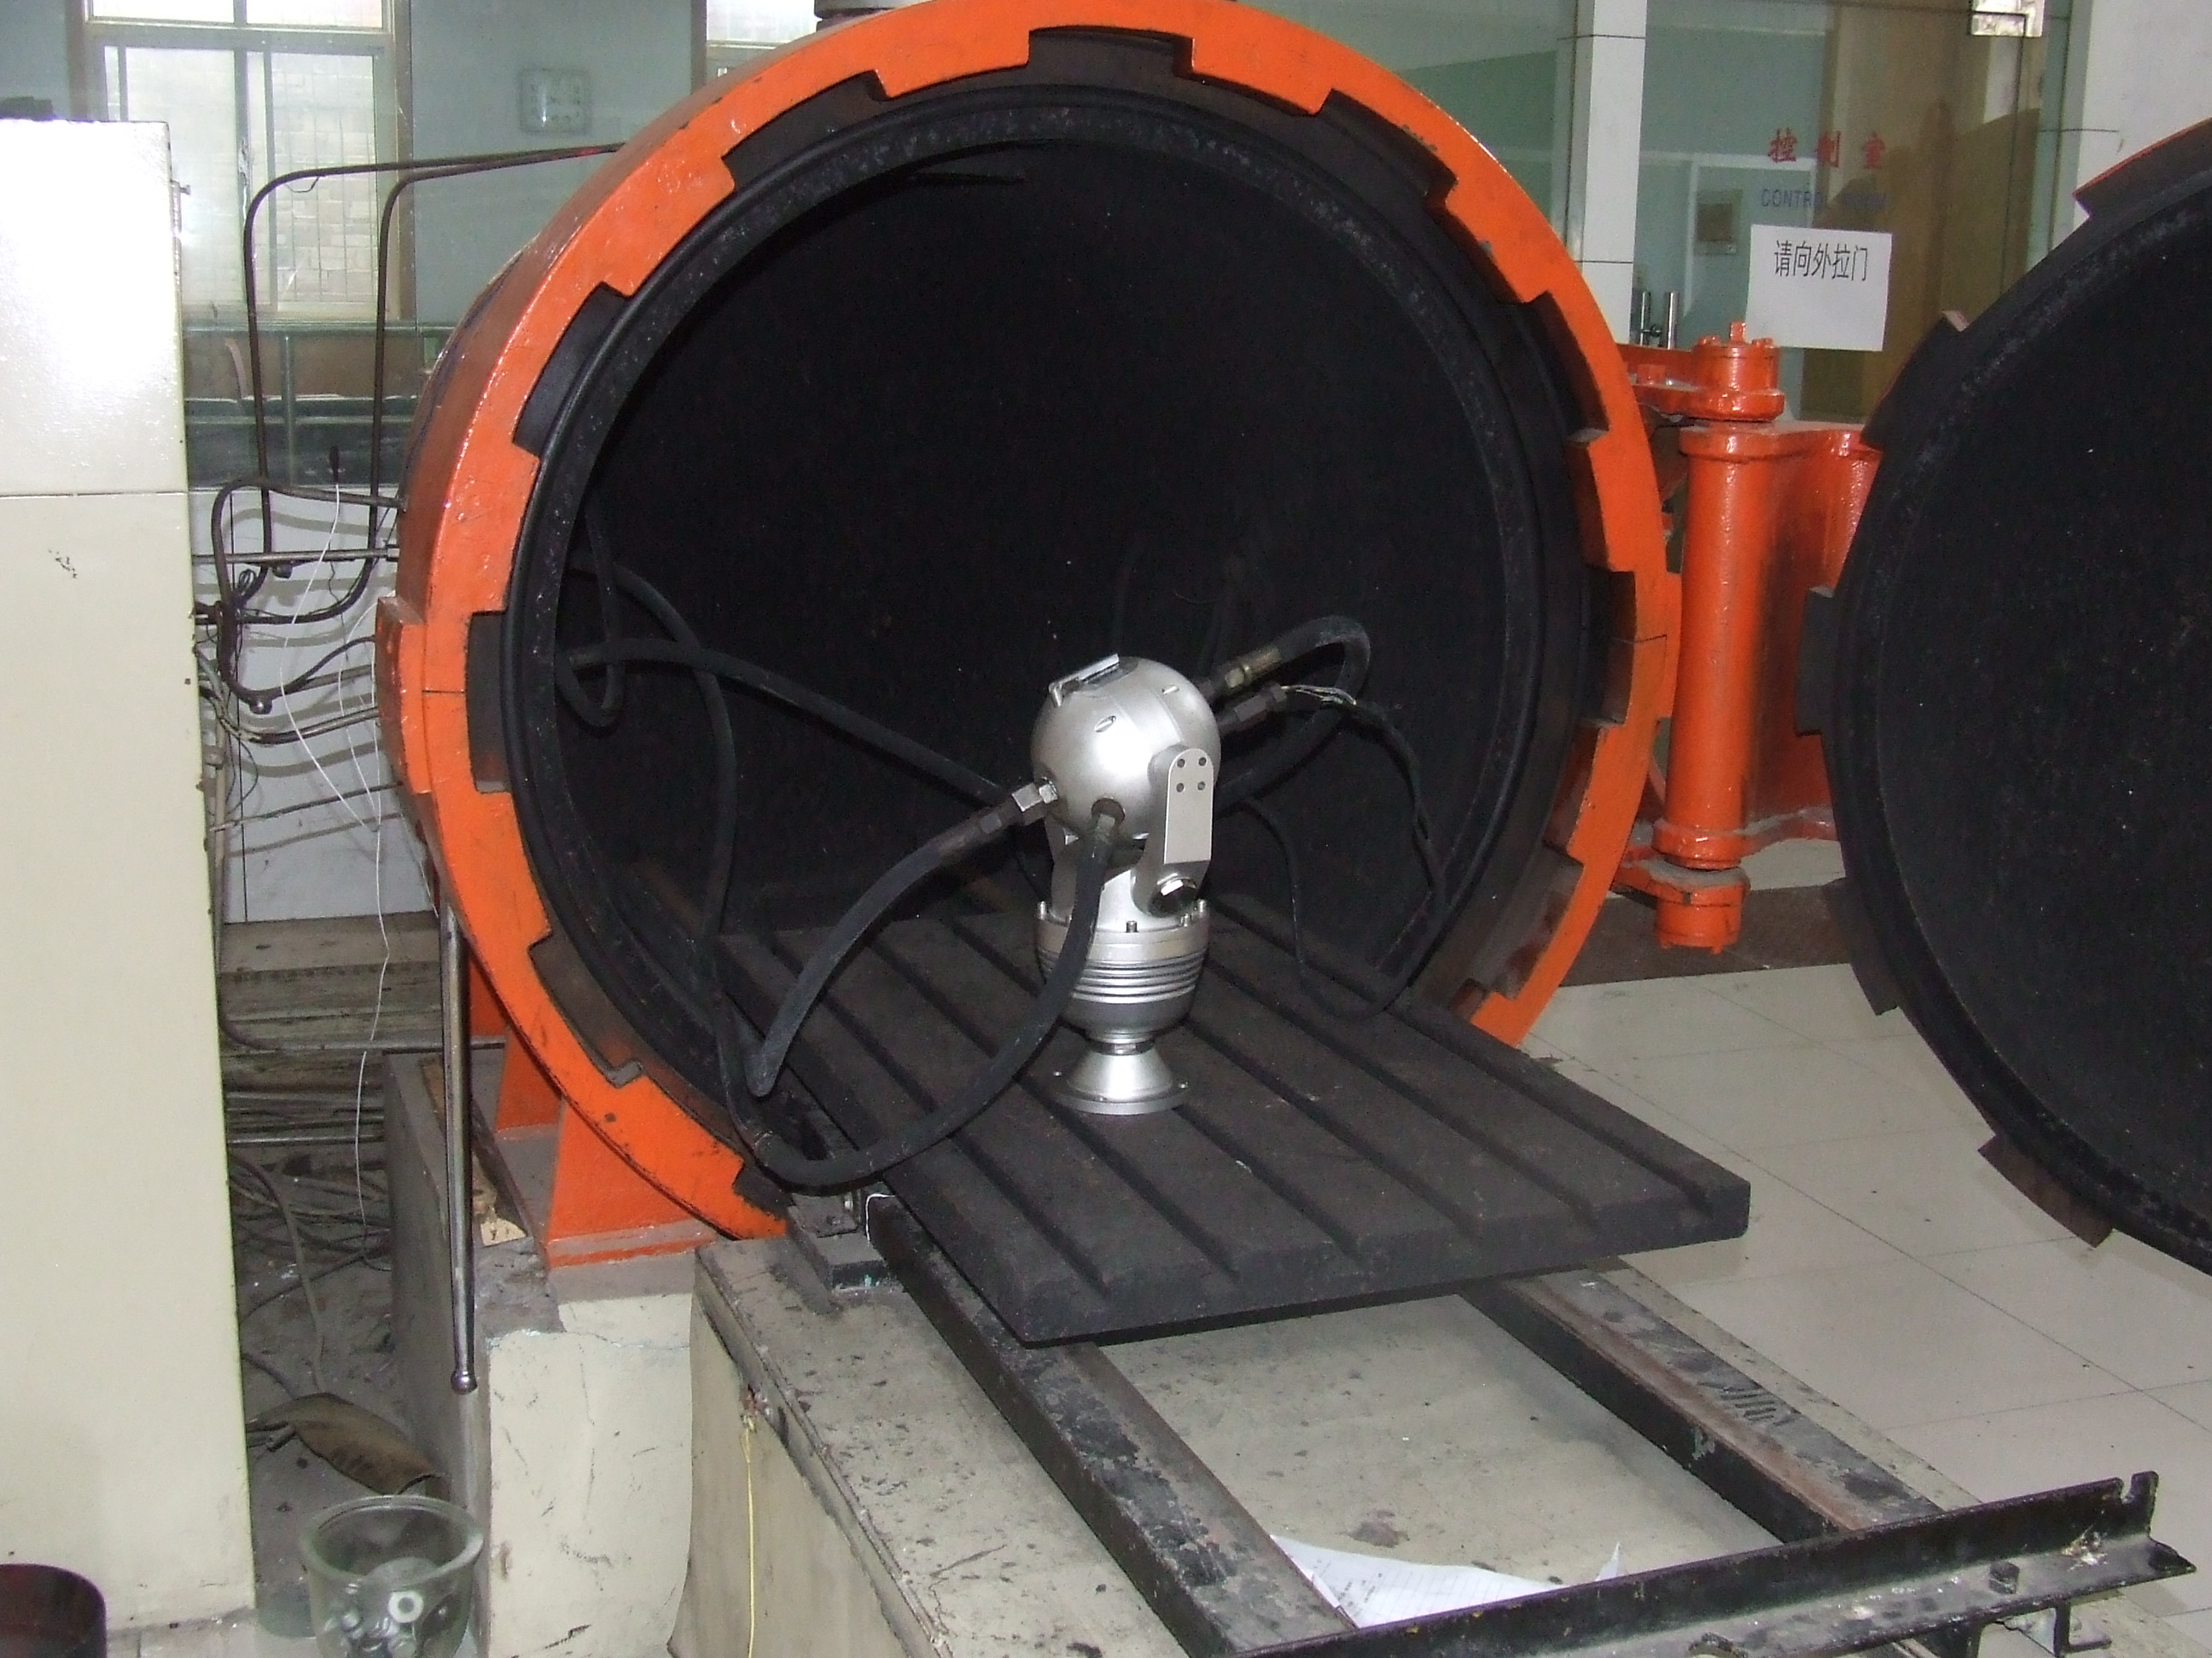
(Above Photo: LeadEx Robot Dome is under explosion proof testing)

STANDARDS & EX MARKING:
Standards as below:
IEC60079-0:2004 - Electrical apparatus for explosive gas atmospheres – Part 0: General requirements
IEC60079-1:2003 - Electrical apparatus for explosive gas atmospheres – Part 1: Flameproof enclosure “d”
GB3836.1-2000 - Electrical apparatus for explosive gas atmospheres – Part 0: General requirements
GB3836.2-2000 - Electrical apparatus for explosive gas atmospheres – Part 1: Flameproof enclosure “d”
Q/LDX001-2007- Enterprise standards for electrical apparatus for explosive gas atmospheres
EN50014 ff - Electrical apparatus for explosive gas atmospheres (Europe Union)

Marking: Exd II CT6
(C15888, C15889, C15890) Exd II CT6.
Approved by CNEx/CQST (in China) Class I Division 1, Groups B, C, and D.
Certified by EC-TYPE EXAMINATION, KEMA 04ATEX2045X, II 2G EExd II CT6, II2D T180 degree centigrade.

CERTIFICATE OF ACCEPTANCE- IECEx Testing Laboratory:

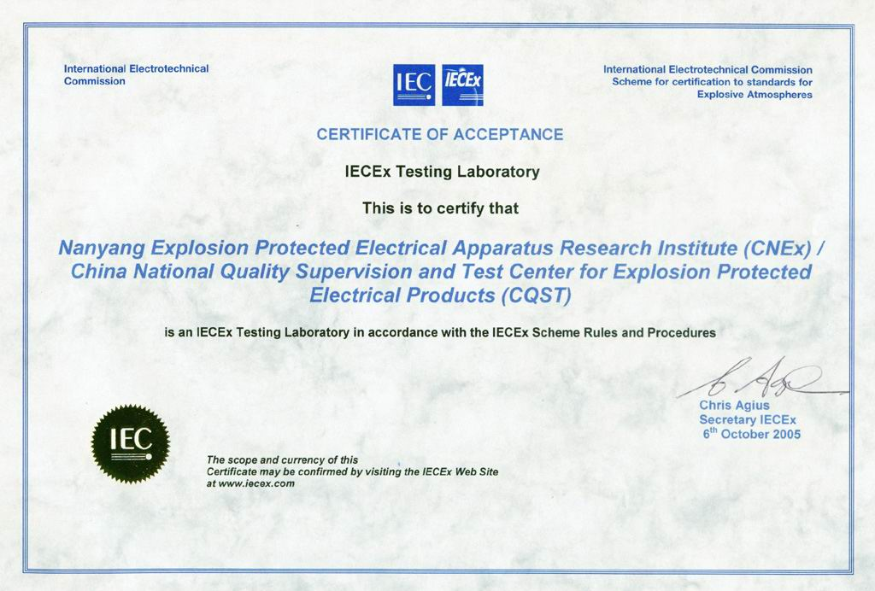

IECEx Member Bodies are listed below:
Australia, Canada, China, Czech Republic, Denmark, Finland, France, Germany, Hungary, India, Italy, Japan, Korea, Netherlands, New Zealand, Norway, Republic of Serbia, Romania, Russia, Singapore, Slovenia, South Africa, Sweden, Switzerland, UK, USA

SOME PHOTOCOPIES OF MUTUAL ACCEPTANCE AGREEMENTS:
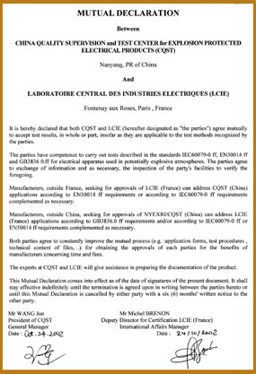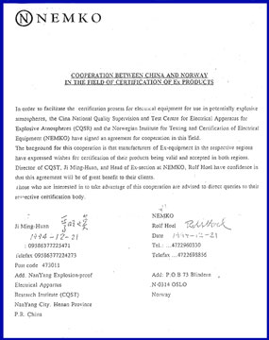

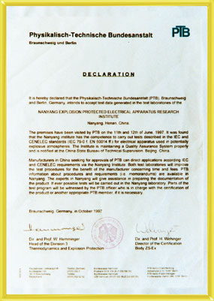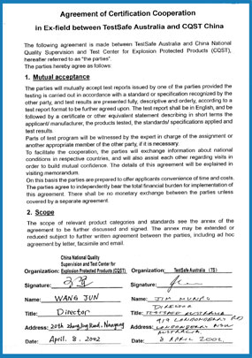

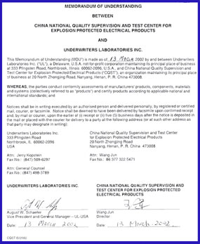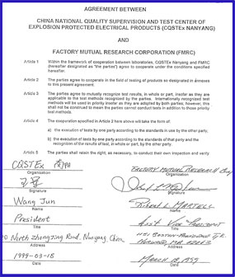

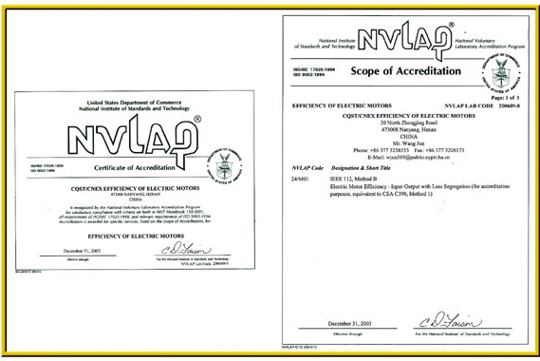

PHOTOCOPIES OF JM612 CERTIFICATE OF CONFORMITY:
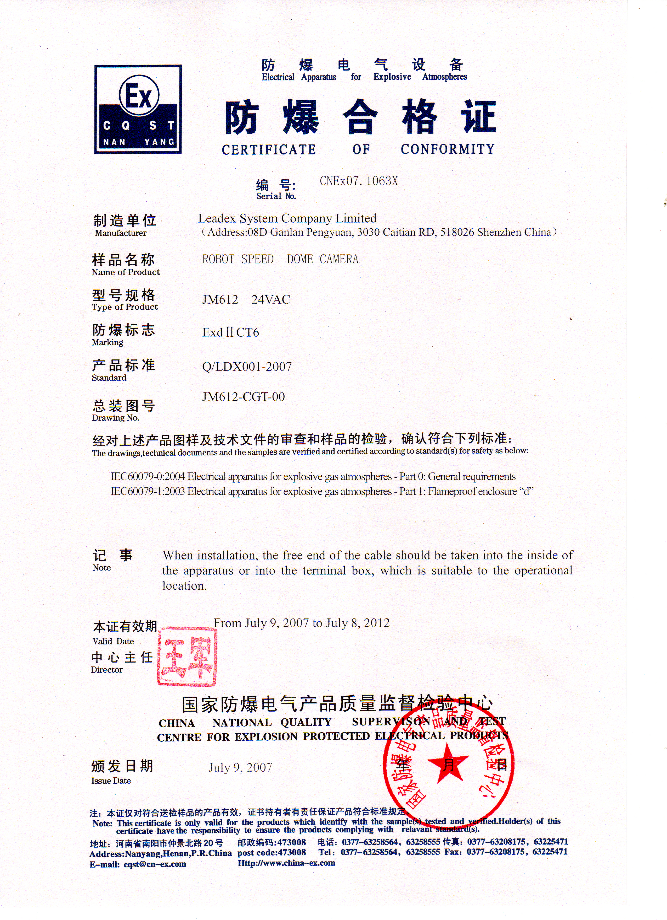 | 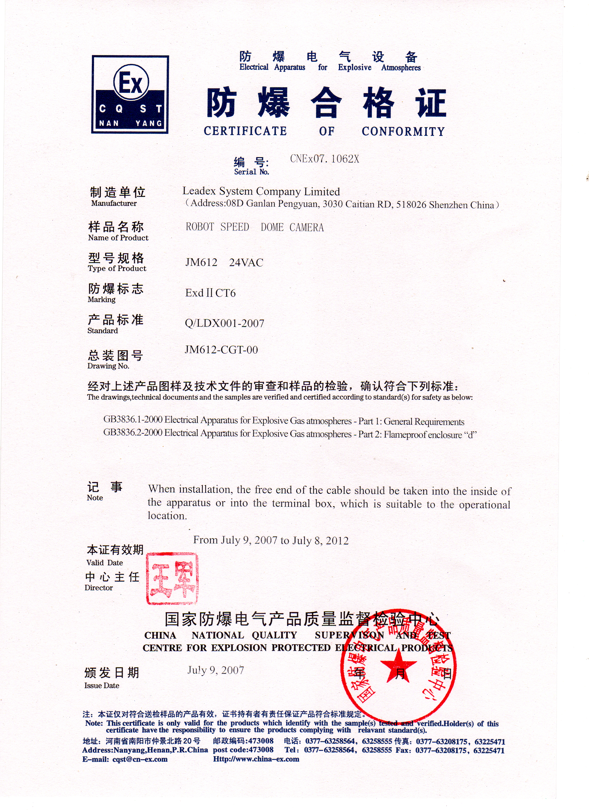

OTHER CERTIFICATION:
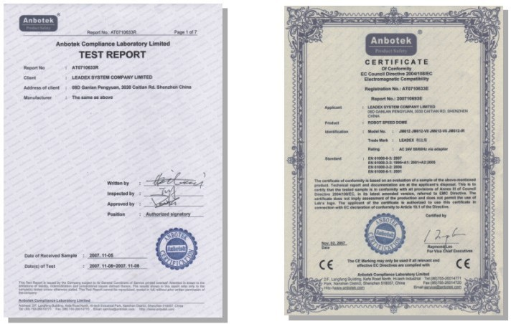
IP66 Test Report CE

