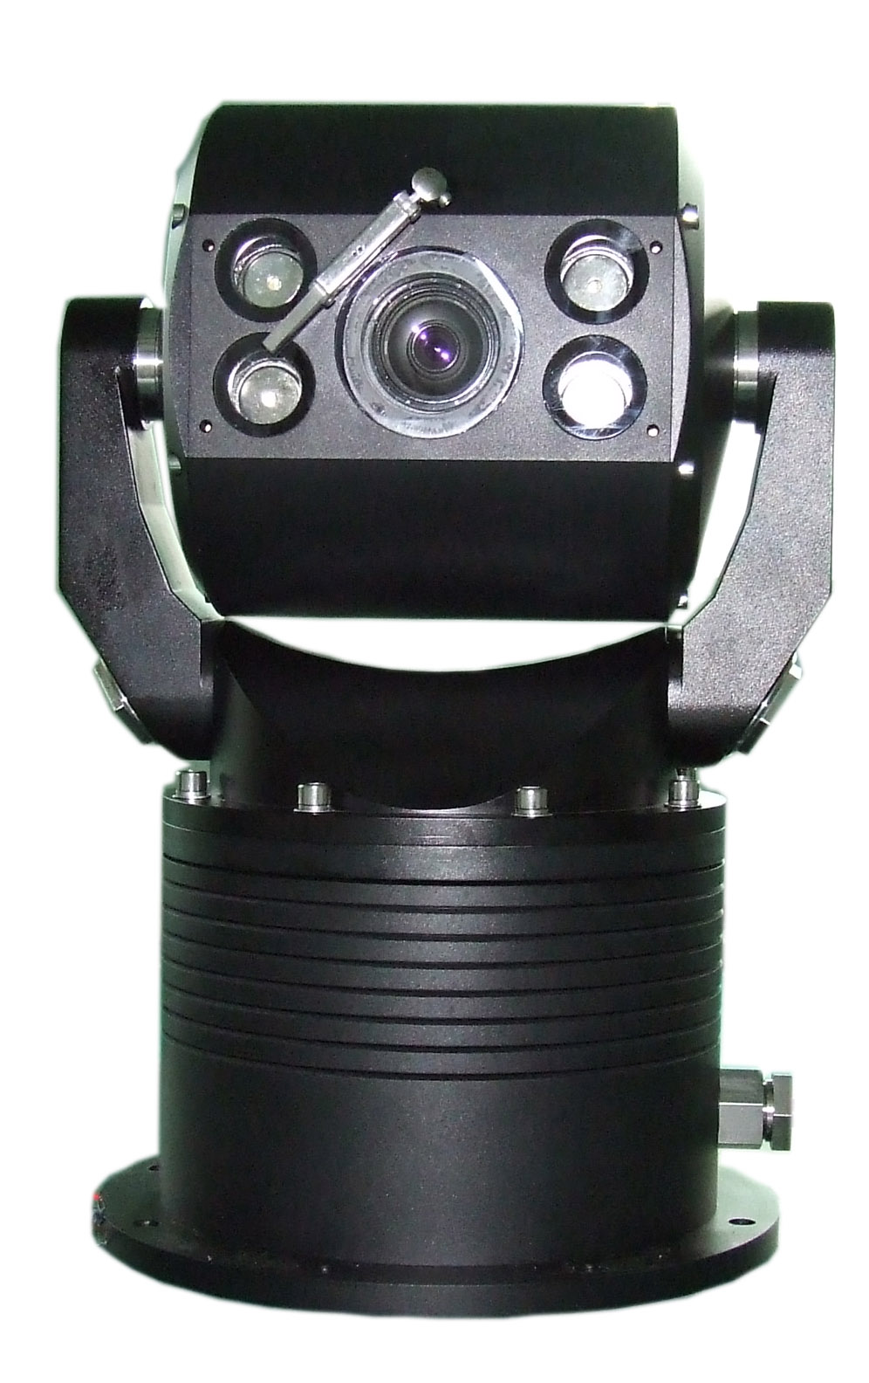
UNIQUE FEATURES:
- Robot Dome body machined from 8mm~22mm thick Aluminum Alloy or 316L# Stainless Steel, true robust design with 4 proofs:
* Explosion proof ( Exd II CT6)
* Bullet proof
* Vandal proof
* Water proof (Sealed to IP66 and NEMA 4X)
- Flat designed optics window from filmed and toughened glass (5mm thick) offers distortion free image and maximum vandal resistant protection for IOP (Integrated Optical Package) camera module.
- All weather conditions working with wiper
- 360º continuous rotation for both pan and tilt
- Built-in long range IR Laser for low lux applications


OTHER FEATURES:
- OSD password protection
- Water wiper guaranteed clear view in heavy rain
- Privacy Zone Masking
- Optional auto tracking
- Optional motion detection
- Unique motor calibration: Manual or Auto
- Easy-to-use DIP switch setup window
- Built-in hi-resolution and big zoom IOP module (See camera SPECS)
- Built-in temperature display & control
- On-Screen-Display programming menu
- On-Screen-Display inside temperature
- On-Screen-Display pan/tilt/zoom position
- User definable temperature alert
- User definable 8 preset tours
- User definable preset frozen
- User definable 128 target presets and PTZ learn pattern
- User definable auto-scan with 1~40 degree/s speed selectable
- User definable power-up action
- User definable left and right pan limitation
- RS-485 Half duplex communication, RS-422 Full duplex (optional)
- Proportional pan speed (optional)
- Surge protection & non-volatile memory
- IP66/CE/FCC/MA/RoHS compliance
- Explosion-proof compliance, IECex and ATX standard rated Exd II CT6

APPLICATIONS:
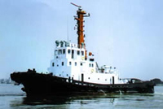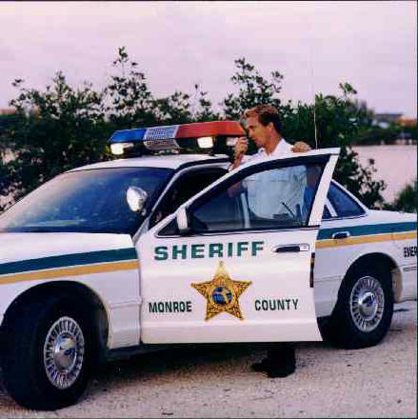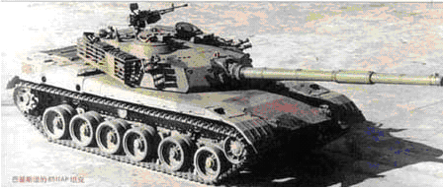
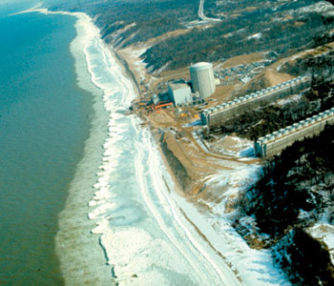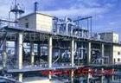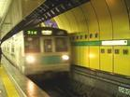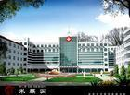

JM612 Series Solid Speed Dome is designed to be resistant to impact from stones, bricks, normal explosion and even short barrel gun bullets. It is ideal for high security and/or hazardous environments applications, such as: Navy, military, nuclear plants, seafronts, harbors, shipping, embassy, police vehicles, armored vehicles, airports, high crime area, and so on.
Specially, because of its explosion proof features, it is very popular in “Hazardous Areas” “Explosive Atmospheres”, and the like and relate to areas where flammable liquids, vapors, gases or combustible dusts are likely to occur in quantities sufficient to cause a fire or explosion.
The modern day automation of industry has met an increased need to use equipment in Ex areas. Such equipment is termed “Ex equipment”, typical applications include:
- Automotive refueling stations or petrol stations
- Oil refineries, rigs and processing plants
- Chemical processing plants
- Printing industries, paper and textiles
- Hospital operating theatres
- Aircraft refueling and hangars
- Surface coating industries
- Underground coal mines
- Sewage treatment plants
- Gas pipelines and distribution centers
- Grain handling and storage
- Woodworking areas
- Sugar refineries
- Metal surface grinding, (especially aluminum dusts and particles)
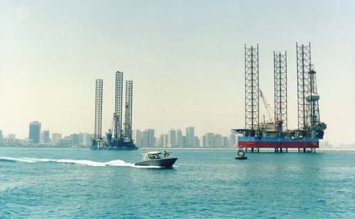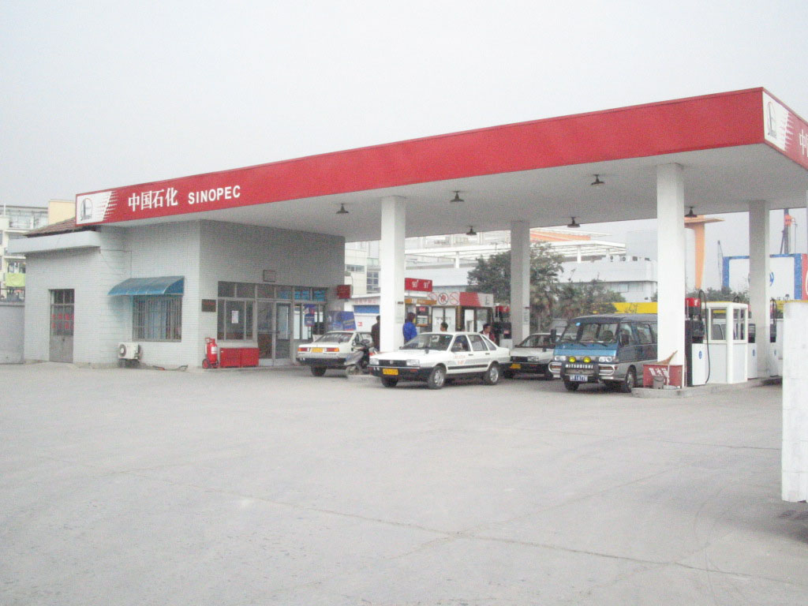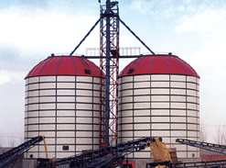
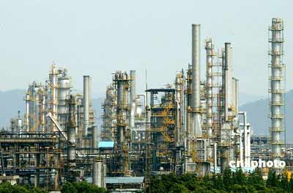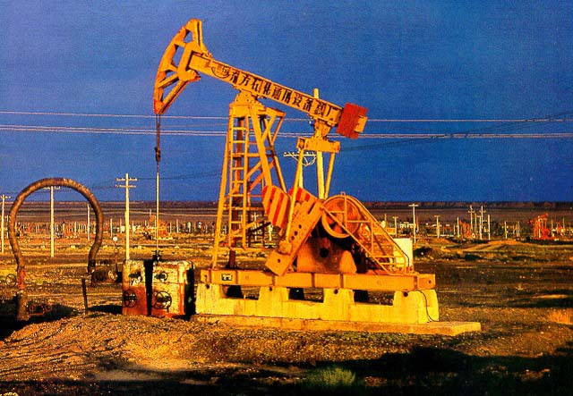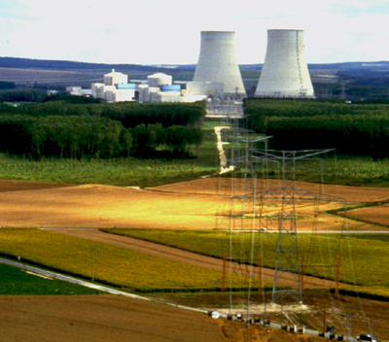
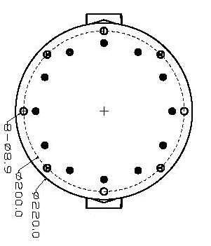
SPECIFICATION
General specification:
- Thickness of Al alloy or stainless steel body: 8mm ~ 22mm
- Thickness of flat designed optics window from filmed and toughened glass: 5mm
- Continues working temperature：-20ºC -- +50ºC
- Storage temperature: -40ºC -- +60ºC
- Dimension：(See Chart)
- weight：10KG （Aluminum Alloy） 22KG (Stainless Steel)
Electric specification：
      - Input voltage: AC 24V
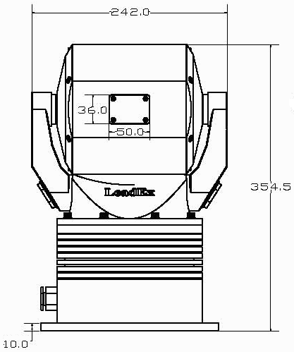
      - Input power: 100VA
Pan/Tilt specification
- Pan/tilt speed: Pan 0.1º-120º/s Tilt: 0.1º-100º/s
- Preset speed： Pan 120º/s Tilt ：100º/s
- Preset accuracy: +/-0.1º (manual or auto calibration available)
- Scan：Automatic preset tour
- Auto scan: 1º-40º/s
- Pan rotation: 360º continues
- Tilt rotation: 360ºcontinues
- Preset: 8 preset tours with dwell time 1~99seconds.
Optional accessories：
- Keyboard controller: LDX-KBD-D

Laser Lamp-house Parameter:：
- Laser electric current: Average 245mA
- Laser working voltage: Average 2050 mV
- Slope efficiency: Average 1.20
- Laser wavelength: 808nm （Please see the Laser spectrogram）
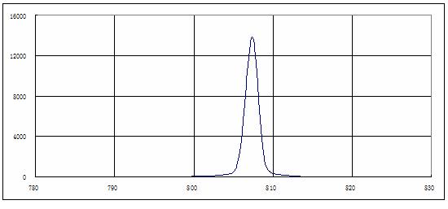
- Electric working current：2000 mA. Electric light efficiency: 2000mW.
- The JM612-IR can hold 4 lasers: maximum power is 8000 mW.
Laser electric current- Power Specification chart. Take the SONY FCB-EX1000P 36X camera module as an example, also see attached camera optics frequency response curve:

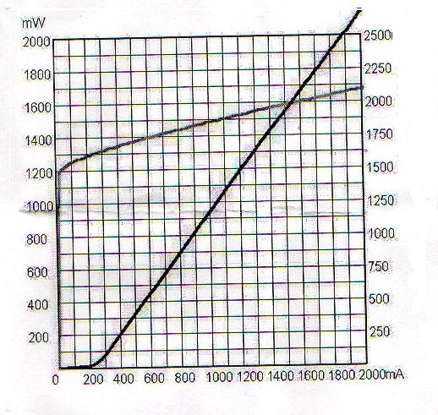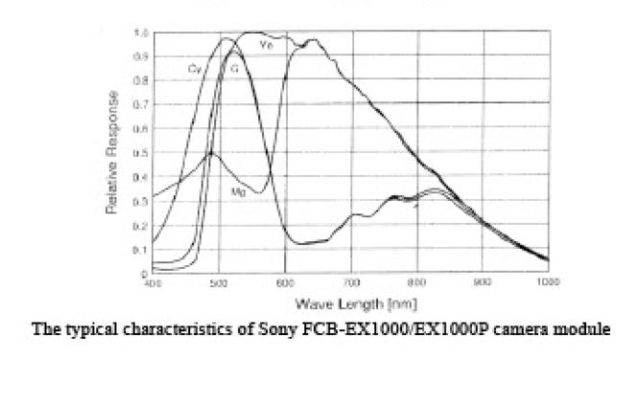
Power Specification chart
Order Guide
Camera module No.  Series |  | 18X Day/Night  (Sony FCB-EX480C) | 26X Day/Night  (Sony FCB-EX980) | 36X Day/Night  (Sony FCB-EX1000) or  (Sony FCB-EX1010)
JM612-V8 | Aluminum Alloy | LDX-JM612A-V8A-18 | LDX-JM612A-V8A-26 | LDX-JM612A-V8A-36
JM612-V8 | Stainless Steel | LDX-JM612S-V8S-18 | LDX-JM612S-V8S-26 | LDX-JM612S-V8S-36
JM612-V6 | Aluminum Alloy | LDX-JM612A-V6A-18 | LDX-JM612A-V6A-26 | LDX-JM612A-V6A-36
JM612-V6 | Stainless Steel | LDX-JM612S-V6S-18 | LDX-JM612S-V6S-26 | LDX-JM612S-V6S-36
JM612-IR | Aluminum Alloy | LDX-JM612A-IR-18 | LDX-JM612A-IR-26 | LDX-JM612A-IR-36
JM612-IR | Stainless Steel | LDX-JM612S-IR-18 | LDX-JM612S-IR-26 | LDX-JM612S-IR-36
Remark: “NTSC” camera will add “N” at the end of model no.
Reference specifications of built-in IOP cameras module:
Model Number |  | 18X Day/Night |  | 26X Day/Night |  |  |  | 36X Day/Night
Signal System |  | NTSC | PAL | NTSC | PAL |  |  | NTSC | PAL
Camera Model |  | FCB-EX480 | FCB-EX480P | FCB-EX980 | FCB-EX980P |  |  | FCB-EX1000  FCB-EX1010 | FCB-EX1000P  FCB-EX1010P
Picture Elements |  | ~380K (768X494) | ~440K (752X582) | ~380K | ~440K |  |  | ~380K | ~440K
Horizontal resolution |  | 480TVL |  | 480TVL |  |  |  | 480TVL(FCB-EX1000/1000P)  530TVL(FCB-EX1010/1010P)
Image Sensor |  | 1/4 type IT CCD (EX view HAD) |  | 1/4’’ Super HAD CCD |  |  |  | 1/4 type EXview HAD CCD
Optical Zoom |  | 18X |  | 26X |  |  |  | 36X
Digital Zoom |  | 12X |  | 12X |  |  |  | 12X
Lens |  | F=4.1mm~73.8mm, F=1.4~3.0 |  | f=3.5mm~91mm, F=1.6~3.8 |  |  |  | f=3.4mm~122.4mm F=1.6~4.5
Angle of View |  | 54.2°(W) to 2.2° (T) |  | 54.2°(W) to 2.2° (T) |  |  |  | 57.8°(W) to 1.7° (T)
Synchronization |  | Internal/External(V-lock) |  | Internal/External(V-lock) |  |  |  | Internal/External(V-lock)
Min. illumination | Color B/W | 0.1Lux/1/4sec  0.01Lux/1/4sec | 0.1Lux/1/3sec  0.01Lux/1/3sec | 0.2Lux/1/4sec  0.01Lux/1/4sec |  | 0.2Lux/1/3sec  0.01Lux/1/3sec |  | 0.1Lux/1/4sec  0.01Lux/1/4sec |  | 0.1Lux/1/3sec  0.01Lux/1/3sec
S/N Ratio |  | >50dB |  | >50dB |  |  |  | >50dB
BLC |  | ON/OFF |  | ON/OFF |  |  |  | ON/OFF
Shutter Speed |  | 1/1 to 1/10000sec | 1/1 to 1/10000sec | 1/4 to 1/10000sec |  |  | 1/3 to 1/10000sec | 1/4 to 1/10000sec |  |  | 1/3 to 1/10000sec
Shutter |  | Auto/Manual |  | Auto/Manual |  |  |  | Auto/Manual
White Balance |  | Auto/Manual |  | Auto/Manual |  |  |  | Auto/Manual
Gain Ctrl |  | Auto/Manual |  | Auto/Manual |  |  |  | Auto/Manual
Video Output |  | VBS:1Vp-p (sync negative), Y/C |  | VBS:1Vp-p (sync negative), Y/C |  |  |  | VBS:1Vp-p (sync negative), Y/C
Iris Ctrl |  | Auto/Manual |  | Auto/Manual |  |  |  | Auto/Manual
Focus Ctrl |  | Auto/Manual |  | Auto/Manual |  |  |  | Auto/Manual
Wide Dynamic |  | No |  | No |  |  |  | Yes (EX-FCB1010) only

Outdoor
Illumination <0.1 Lux，
The distance is about 100 meters between the IR Robot and the target with red mark
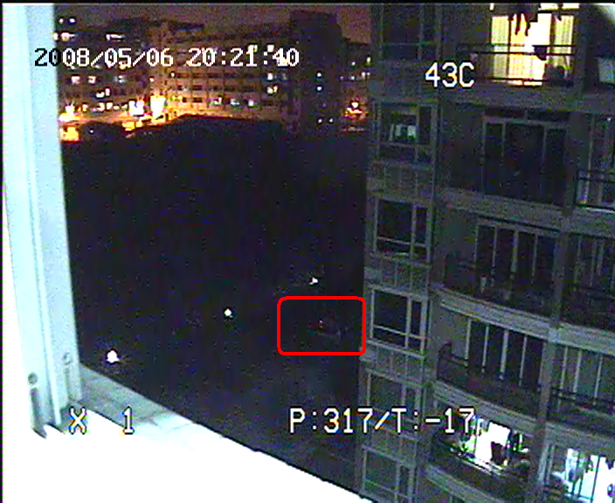 | 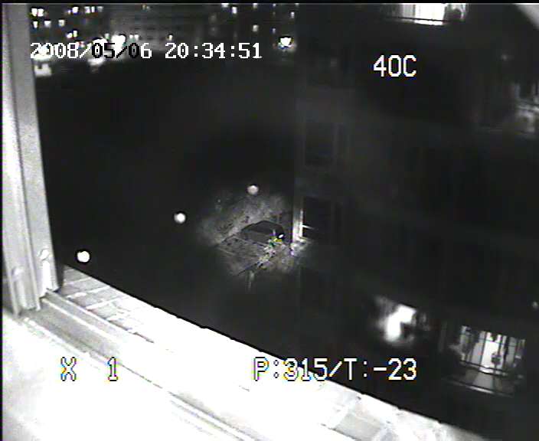
Zoom 1 x Laser off | Zoom 1 x Laser on
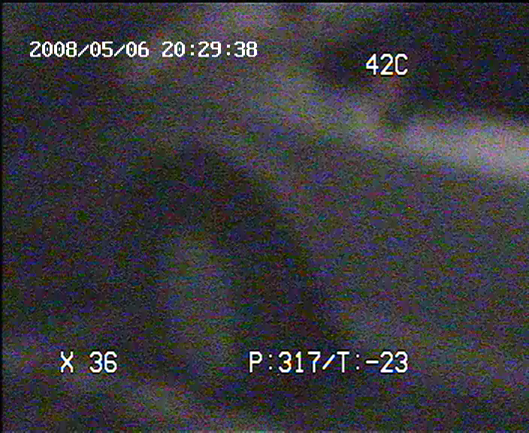 | 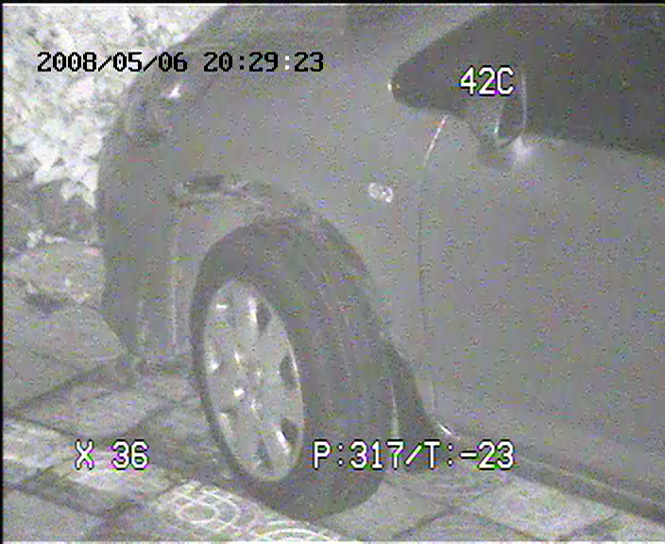
Zoom 36x Laser off | Zoom 36x Laser on

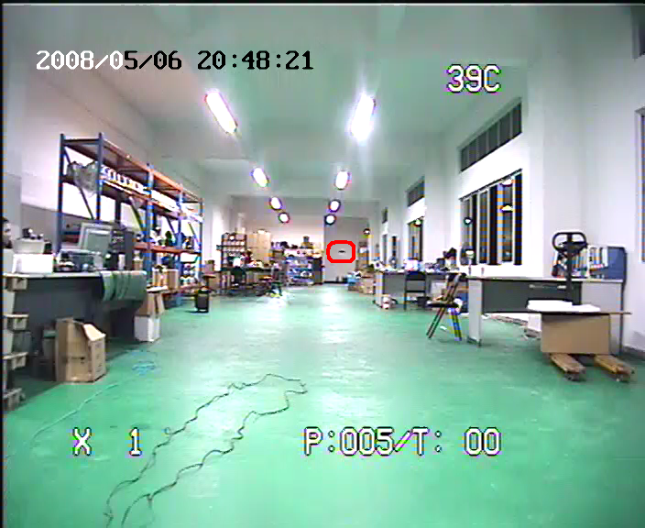

Indoor
Illumination <0.01 Lux，
The distance is about 50 meters between the IR Robot and the target with red mark
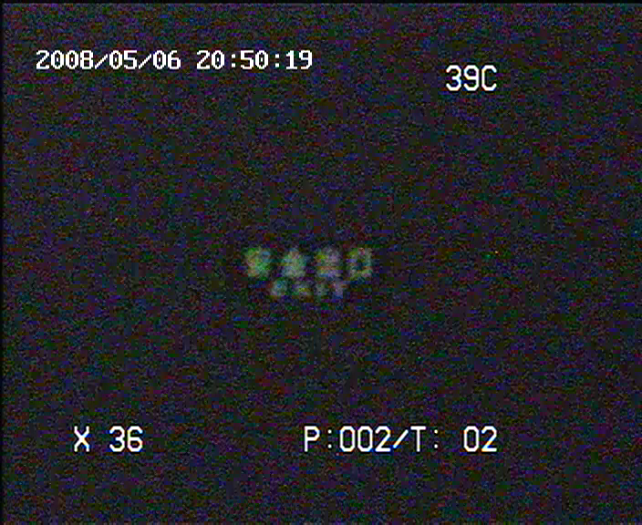 | 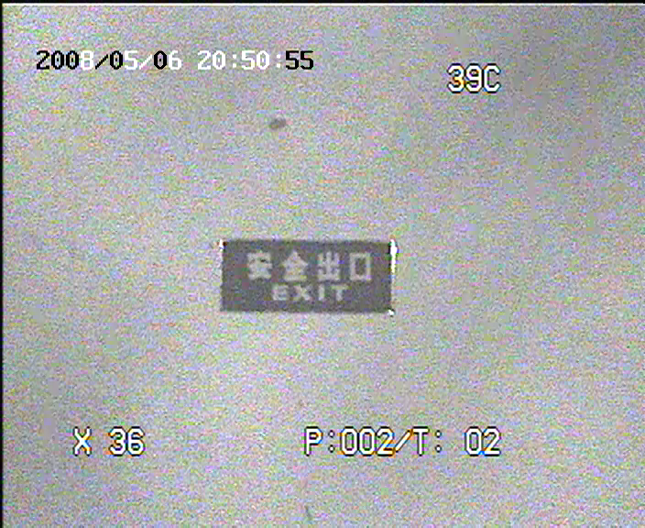
Zoom 36x Laser off | Zoom 36 x Laser on

